TABLE OF CONTENTS

HTML Element 2

HTML Headings 3

HTML Paragraphs 4

The Link tag 5

The Image tag 6

HTML Comments 8

HTML Text Formatting 9

HTML Lists 10

HTML Form 12

HTML Canvas Graphics 15

HTML Tables 16

HTML Frames 19

HTML Global Tags 21

Inserting CSS 22

Inline CSS Code: 22

Internal CSS Code: 23

External CSS code: 24

CSS Box Model 25

CSS Margin 27

CSS Padding 28

Responsive Web Design - Media Queries 29

Javascript Statements 31

Javascript Functions 32

IF Statements 33

FOR LOOP 34

Javascript Arrays 35

Javascript Constructors 37

Cookies 38

XML 40

Accessing Form Elements with PHP 41

PHP Class and Objects 42

# HTML Element

The HTML **element** is everything from the start tag to the end tag:

### Code:

### 

<!DOCTYPE html>

<html>

<body>

Hello World!!

</body>

</html>

### Output:

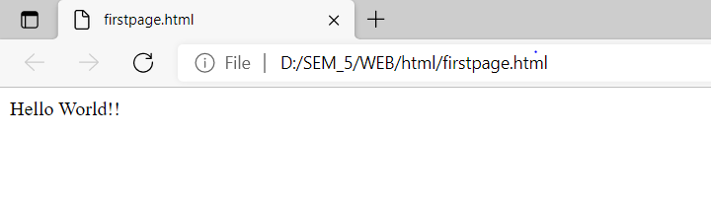

# HTML Headings

HTML headings are titles or subtitles that you want to display on a webpage. HTML headings are defined with the <h1> to <h6> tags.<h1> defines the most important heading. <h6> defines the least important heading.

### Code:

<!DOCTYPE html>

<html>

<body>

<h1>Heading 1</h1>

<h3>Heading 3</h3>

<h4>Heading 4</h4>

<h6>Heading 6</h6>

</body>

</html>

### Output:

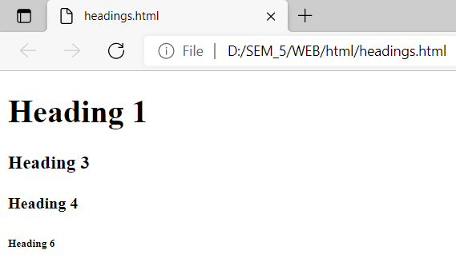

# HTML Paragraphs

The HTML <p> element defines a paragraph.A paragraph always starts on a new line, and browsers automatically add some white space (a margin) before and after a paragraph.

### Code:

<!DOCTYPE html>

<html>

<body>

<p>This is a paragraph.</p>

<p>This is a paragraph.</p>

<p>This is a paragraph.</p>

</body>

</html>

### Output:

### 

# The Link tag

The <a> tag defines a hyperlink. The href attribute specifies the URL of the page the link goes to

### Code:

<!DOCTYPE html>

<html>

<body>

<a href="https://www.github.com">Visit GITHUB!</a>

</body>

</html>

### Output:



# The Image tag

The <img> tag is used to embed an image in an HTML page. The src attribute specifies the path to the image to be displayed.

### Code:

<!DOCTYPE html>

<html>

<body>

<img src="CS1.jpg" width="500" height="400">

</body>

</html>

### Output:

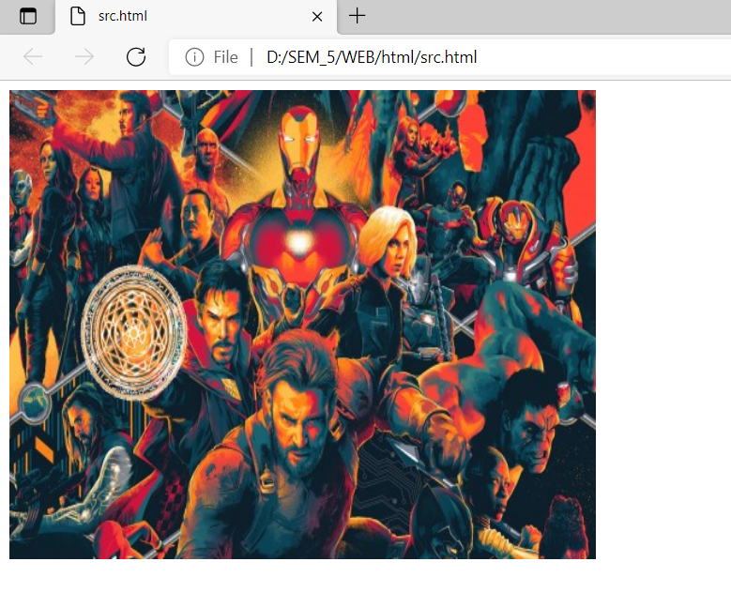

There are two ways to specify the URL in the src attribute:

1. **Absolute URL** - Links to an external image that is hosted on another website. Example: src="https://www.w3schools.com/images/img_girl.jpg".
2. **Relative URL -** Links to an image that is hosted within the website. Here, the URL does not include the domain name. If the URL begins without a slash, it will be relative to the current page. Example: src="CS1.jpg". If the URL begins with a slash, it will be relative to the domain. Example: src="/images/CS1.jpg".

**Code:**

<!DOCTYPE html>

<html>

<head>

<title>Absolute Addressing in HTML with IMAGE</title>

</head>

<body>

<h1> Absolute image path</h1>

<img src="https://assets-cdn.kantipurdaily.com/uploads/source/news/kantipur/2021/third-party/pfizer-2192021024628-1000x0.jpg"&gt; width=”200” height=”200”/>

</body>

</html>

</html>

</html>

</html>

**Output:**



# HTML Comments

HTML comments are not displayed in the browser, but they can help document your HTML source code.

### Code:

<!DOCTYPE html>

<html>

<body>

<!-- This is a comment -->

<p>This is a paragraph.</p>

<!-- Comments are not displayed in the browser -->

</body>

</html>

### Output:

### 

# HTML Text Formatting

### Code:

<!DOCTYPE html>

<html>

<body>

<p><b>This text is bold</b></p>

<p><small>This is some smaller text.</small></p>

<p><i>This text is italic</i></p>

<p>This is<sub> subscript</sub> and <sup>superscript</sup></p>

<p><strong>This text is important!</strong></p>

<p style="color:red;">This is a red paragraph.</p>

</body>

</html>

### Output:

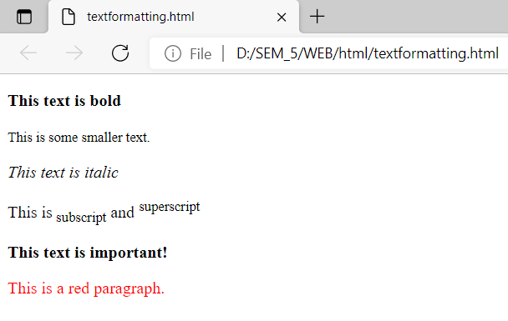

# HTML Lists

### Code:

<html>

<head>

<title>Ordered and Unordered LIst</title>

</head>

<body>

<h1>Ordered List</h1>

<ol type="A" start="3">

<li>Web</li>

<li>Simulation</li>

<li>SAD</li>

</ol>

<h1>Unordered list</h1>

<ul type="circle" >

<li>Ram</li>

<li>Shyam</li>

<li>Hari</li>

</ul>

<h1>Nested List</h1>

<ol type="1">

<li>Subjects

<ol type="a">

<li>Math</li>

<li>Eco</li>

<li>Science</li>

</ol>

</li>

<li>Cars

<ol type="a">

<li>Lambo</li>

<li>Ferrari</li>

</ol>

</li></ol>

<h1>Definition List</h1>

<dl><dt>CPU</td>

<dd>Central Processing Unit</dd>

<dt>HTML</td>

<dd>Hyper text Markup Language</dd>

</dl>

<h1>The datalist elementas Auto complete Textbox</h1>

Enter Name <input list="studentnames">

<datalist id="studentnames">

<option>Ram</option>

<option>Shyam</option>

</datalist>

</body></html>

<h1>The datalist elementas Auto complete Textbox</h1>

Enter Name <input list="studentnames">

<datalist id="studentnames">

<option>Ram</option>

<option>Shyam</option>

</datalist>

</body></html>

### Output:

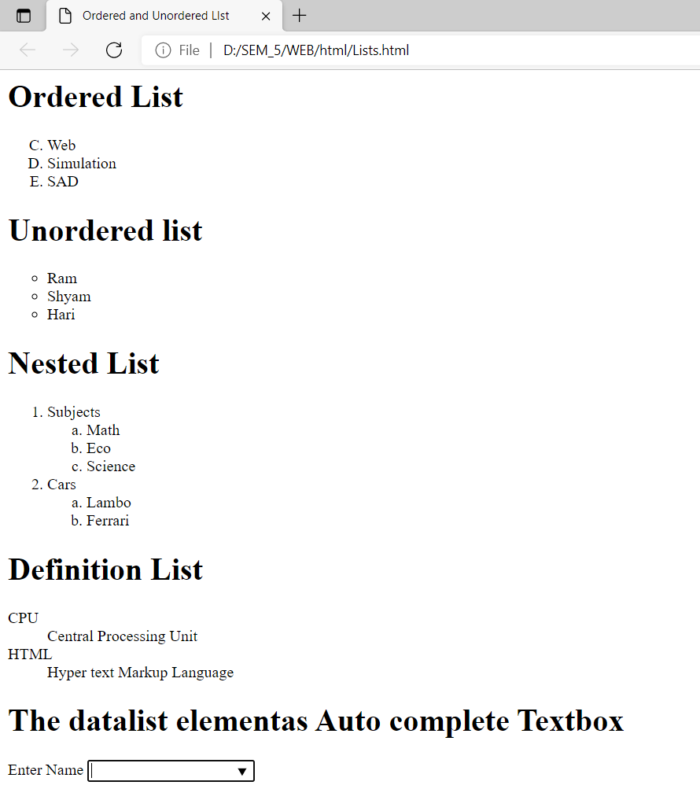

# HTML Form

### Code:

<html>

<head>

<title>Student Registration Form</title>

</head>

<body>

<form>

<h1>Student Registration</h1>

<table>

<tr>

<td>Name</td>

<td><input type="text"required></td>

</tr>

<tr>

<td>Email ID</td>

<td><input type="email" placeholder="Entr Email"></td>

</tr>

<tr>

<td>UserName</td>

<td<input type="email"></td>

</tr>

<tr>

<td>Password</td>

<td><input type="password" disabled></td>

</tr>

<tr>

<td>Confirm Password</td>

<td><input type="password" readonly></td>

</tr>

<tr>

<td>Gender</td>

<td>

<input type="radio" name="gender">Male<br>

<input type="radio" name="gender">Female<br>

20

<input type="radio" name="gender">Other<br>

</td>

</tr>

<tr>

<td>Fav. Color</td>

<td><input type="color"></td>

</tr>

<tr>

<td>Upload Profile PIcture</td>

<td><input type="file" required ></td>

</tr>

<tr>

<td>Expected Salary</td>

<td><input type="range" min="0" max=100"></td>

</tr>

<tr>

<td>Pincode</td>

<td><input type="number"></td>

</tr>

<tr>

<td>Address</td>

<td><textarea></textarea></td>

</tr>

<tr>

<td>DOB</td>

<td><input type="date"></td>

</tr>

<tr>

<td>How you Hear Us</td>

<td>

<select Multiple>

<option>Tv</option>

<option>Social Media</option>

<option>Radio</option>

<option>Friends</option>

</select>

</td>

21

</tr>

<tr>

<td>Select Course to apply</td>

<td>

<select >

<option>BBA</option>

<option>BBA BI</option>

<option>BCA</option>

<option>BHM</option>

</select>

</td>

</tr>

<tr>

<td>Agreen and Submit</td>

<td>

<input type="checkbox">Agree<br>

<input type="submit" value="Save" accesskey="s">

</td>

</tr>

</table>

</form>

</body>

</html>

### Output:

</td>

</tr>

<tr>

<td>Agreen and Submit</td>

<td>

<input type="checkbox">Agree<br>

<input type="submit" value="Save" accesskey="s">

</td>

</tr>

</table>

</form>

</body>

</html>

</select>

</td>

</tr>

<tr>

<td>Agreen and Submit</td>

<td>

<input type="checkbox">Agree<br>

<input type="submit" value="Save" accesskey="s">

</td>

</tr>

</table>

</form>

</body>

</html>

<td><input type="color"></td>

</tr>

<tr>

<td>Upload Profile PIcture</td>

<td><input type="file" required ></td>

</tr>

<tr>

<td>Expected Salary</td>

<td><input type="range" min="0" max=100"></td>

</tr>

<tr>

<td>Pincode</td>

<td><input type="number"></td>

</tr>

<tr>

<td>Address</td>

<td><textarea></textarea></td>

</tr>

<tr>

<td>DOB</td>

<td><input type="date"></td>

</tr>

<tr>

<td>How you Hear Us</td>

<td>

<select Multiple>

<option>Tv</option>

<option>Social Media</option>

<option>Radio</option>

<option>Friends</option>

</select>

</td>

21

</tr>

<tr>

<td>Select Course to apply</td>

<td>

<select >

<option>BBA</option>

<option>BBA BI</option>

<option>BCA</option>

<option>BHM</option>

</select>

</td>

</tr>

<tr>

<td>Agreen and Submit</td>

<td>

<input type="checkbox">Agree<br>

<input type="submit" value="Save" accesskey="s">

</td>

</tr>

</table>

</form>

</body>

</html>

### Output:

### 

# HTML Canvas Graphics

### Code:

<!DOCTYPE html>

<html>

<body>

<canvas id="myCanvas" width="200" height="100" style="border:1px solid #000000;">

</canvas>

</body>

</html>

### Output:

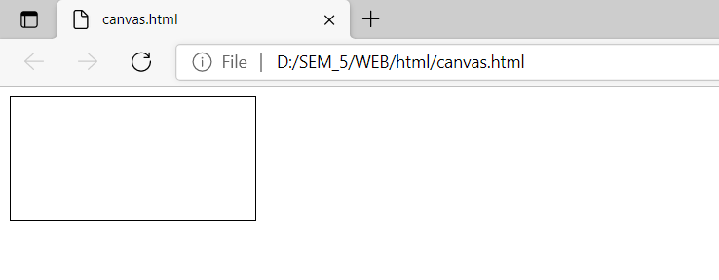

# HTML Tables

### Code:

<html>

<head>

<title> Tables In HTMl</title>

</head>

<body>

<h1> Simple table (old way)</h1>

<table border="1" width="500" bgcolor="pink" cellspacing="10" cellpadding="10" bordercolor="red">

<caption>Student List</caption>

<tr>

<td>Name</td>

<td>Age</td>

<td>RollNumber</td>

</tr>

<tr>

<td>Ram</td>

<td>34</td>

<td>12</td>

</tr>

<tr>

<td>Shyam</td>

<td>23</td>

<td>23</td>

</tr>

<tr>

<td>Total</td>

<td>2</td>

<td>2</td>

</tr>

</table>

<br>

<br>

<h1> Simple table (new way) dividing sections</h1>

<table border="1" width="500" bgcolor="pink" cellspacing="10" cellpadding="10" bordercolor="red";>

17

<caption>Student List</caption>

<thead>

<tr>

<td>Name</td>

<td>Age</td>

<td>RollNumber</td>

</tr>

</thead>

<tbody>

<tr>

<td>Ram</td>

<td>34</td>

<td>12</td>

</tr>

<tr>

<td>Shyam</td>

<td>23</td>

<td>23</td>

</tr>

</tbody>

<tfoot>

<tr>

<td>Total</td>

<td>2</td>

<td>2</td>

</tr>

</tfoot>

</table>

<h1> Mixing Cells</h1>

<table border="1">

<tr>

<td colspan="3"> student Statostics</td>

</tr>

<tr>

<td rowspan="2">Class</td>

<td>Boys</td>

<td>Gisl</td>

18

</tr>

<tr>

<td>20</td>

<td>25</td>

</tr>

<tr>

<td colspan="2">Toatl</td>

<td>45</td>

</tr>

</table>

</body>

</html>

<tr>

<td>Name</td>

<td>Age</td>

<td>RollNumber</td>

</tr>

</thead>

<tbody>

<tr>

<td>Ram</td>

<td>34</td>

<td>12</td>

</tr>

<tr>

<td>Shyam</td>

<td>23</td>

<td>23</td>

</tr>

</tbody>

<tfoot>

<tr>

<td>Total</td>

<td>2</td>

<td>2</td>

</tr>

</tfoot>

</table>

<h1> Mixing Cells</h1>

<table border="1">

<tr>

<td colspan="3"> student Statostics</td>

</tr>

<tr>

<td rowspan="2">Class</td>

<td>Boys</td>

<td>Gisl</td>

18

</tr>

<tr>

<td>20</td>

<td>25</td>

</tr>

<tr>

<td colspan="2">Toatl</td>

<td>45</td>

</tr>

</table>

</body>

</html>

</tr>

</thead>

<tbody>

<tr>

<td>Ram</td>

<td>34</td>

<td>12</td>

</tr>

<tr>

<td>Shyam</td>

<td>23</td>

<td>23</td>

</tr>

</tbody>

<tfoot>

<tr>

<td>Total</td>

<td>2</td>

<td>2</td>

</tr>

</tfoot>

</table>

<h1> Mixing Cells</h1>

<table border="1">

<tr>

<td colspan="3"> student Statostics</td>

</tr>

<tr>

<td rowspan="2">Class</td>

<td>Boys</td>

<td>Gisl</td>

18

</tr>

<tr>

<td>20</td>

<td>25</td>

</tr>

<tr>

<td colspan="2">Toatl</td>

<td>45</td>

</tr>

</table>

</body>

</html>

</tr>

<tr>

<td colspan="2">Toatl</td>

<td>45</td>

</tr>

</table>

</body>

</html>

### Output:

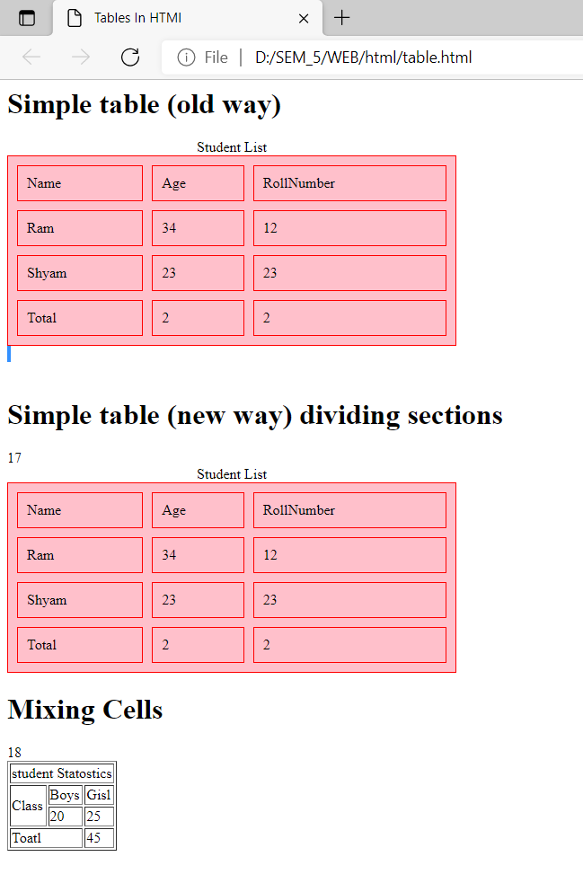

# HTML Frames

### Code:

<html>

<head>

<title>Frames in HTML</title>

</head>

<frameset rows="30%,40%,30%">

<frame src="links.html"></frame>

<frame src="Lists.html"></frame>

<frame src="table.html"></frame>

<noframes>

<body>your browser doesnot support frame</body>

</noframes>

</frameset>

</html>

### Code:

<!-- floating frames --!>

<html>

<head>

<title>floating frame (iframe) in HTML</title>

</head>

<body>

<iframe src="table.html" width="500" height="500"></iframe>

<iframe src="links.html" width="500" height="500"></iframe>

<iframe src="Lists.html" width="500" height="500"></iframe>

<body>

</html>

# 

### Output:

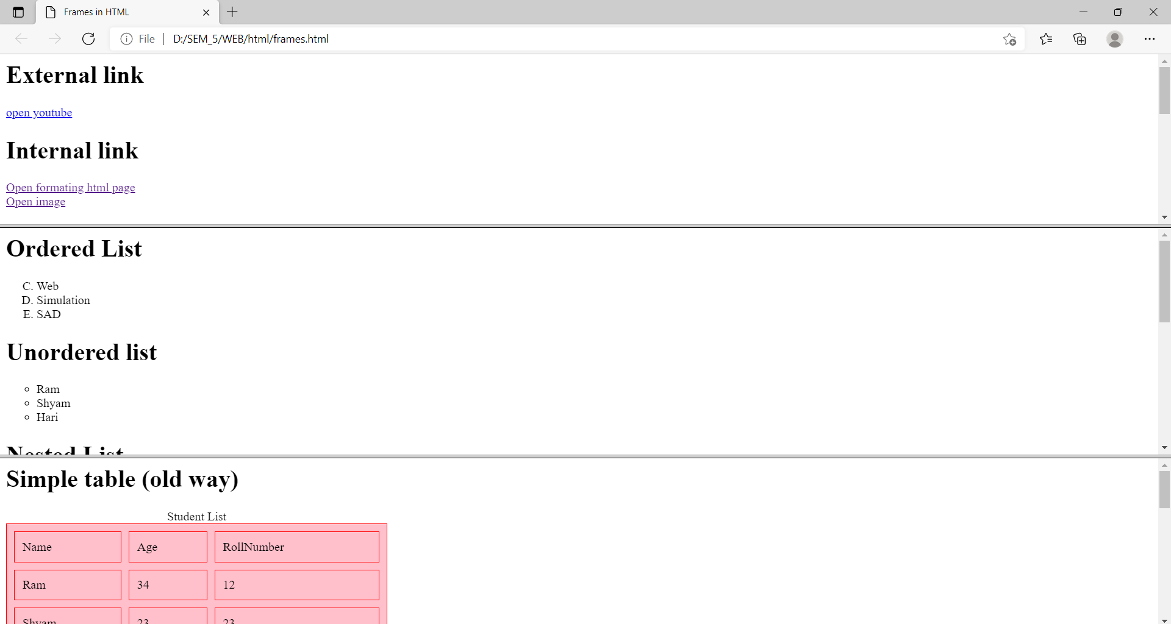

# HTML Global Tags

### Code:

<html>

<head>

<title>HTML Global Attributes</title>

<meta charset="UTF-8">

<meta name="description" content="Free Web tutorials">

<meta name="keywords" content="HTML, CSS, JavaScript">

<meta name="author" content="John Doe">

<meta name="viewport" content="width=device-width, initial-scale=1.0">

</head>

<body>

<ol>

<li>id</li>

<li>class</li>

<li>accesskey</li>

<li>spellcheck</li>

<li>lang</li>

<li>style</li>

</ul>

<p contenteditable="true" spellcheck="true" style="color:red;">

My name is Khan and I am not a terrorist.</p>

</body>

</html>

### Output:

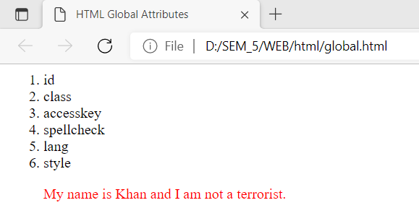

# Inserting CSS

Cascading Style Sheet(CSS) is used to set the style in web pages that contain HTML elements. It sets the background color, font-size, font-family, color, … etc property of elements on a web page.

### Inline CSS Code:

<!DOCTYPE html>

<html>

    <head>

        <title>Inline CSS</title>

    </head>

    <body>

        <p style = "color:#009900; font-size:50px;

                font-style:italic; text-align:center;">

           LICT

        </p>

    </body>

</html>

### Internal CSS Code:

<!DOCTYPE html>

<html>

    <head>

        <title>Internal CSS</title>

        <style>

            .main {

                text-align:center;

            }

            .GFG {

                color:#009900;

                font-size:50px;

                font-weight:bold;

            }

            .lict {

                font-style:bold;

                font-size:20px;

            }

        </style>

    </head>

    <body>

        <div class = "main">

            <div class ="GFG">LICT</di

            <div class ="lict">

                A computer science Campus

            </div>

        </div>

    </body>

</html>

### External CSS code:

/* external.css */

body {

    background-color:powderblue;

}

.main {

    text-align:center;

}

.GFG {

    color:#009900;

    font-size:50px;

    font-weight:bold;

}

#lict {

    font-style:bold;

    font-size:20px;

}

<!DOCTYPE html>

<html>

<head>

<link rel="stylesheet" href="external.css"/>

<title>External CSS</title>

</head>

<body>

<div class = "main">

<div class ="GFG">LICT</div>

<div id ="lict">

A computer science Campus

</div>

</div>

</body>

</html>

### Output:

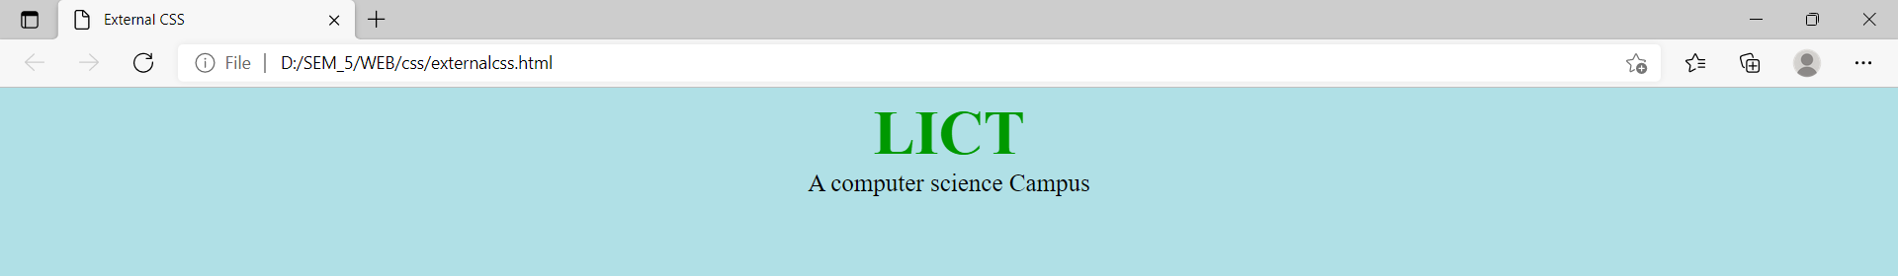

# CSS Box Model

### Code:

<!DOCTYPE html>

<html lang="en">

<head>

    <meta charset="UTF-8">

    <meta http-equiv="X-UA-Compatible" content="IE=edge">

    <meta name="viewport" content="width=device-width, initial-scale=1.0">

    <title>Colors Background And Borders</title>

    <style>

        #mydiv

        {

            width:500px;

            height:400px;

            background-color: red;

            background-image: url("uttu.jpg");

            border-radius: 300px 300px 300px 300px;

            border: 5px solid #11ff33;

        }

        #h1

        {

            font-family: 'Franklin Gothic Medium', 'Arial Narrow', Arial, sans-serif;

            font-size: 25px;

            letter-spacing: 2px;

            word-spacing: 2px;

            color: #000000;

            font-weight: 700;

            text-decoration: line-through solid rgb(68, 68, 68);

            font-style: italic;

            font-variant:normal;

            text-transform:capitalize;

        }

    </style>

</head>

<body>

    <div id="mydiv"></div>

    <h1 id="h1">Hello This is heading1 and we are studying CSS.</h1>

</body>

</html>

## 

## Output:

### Output:

## 

# CSS Margin

### Code:

<!DOCTYPE html>

<html>

<head>

<style>

div {

  border: 1px solid black;

  margin-top: 100px;

  margin-bottom: 100px;

  margin-right: 150px;

  margin-left: 80px;

  background-color: lightblue;

}

</style>

</head>

<body>

<h2>Using individual margin properties</h2>

<div>This div element has a top margin of 100px, a right margin of 150px, a bottom margin of 100px, and a left margin of 80px.</div>

</body>

</html>

### Output:

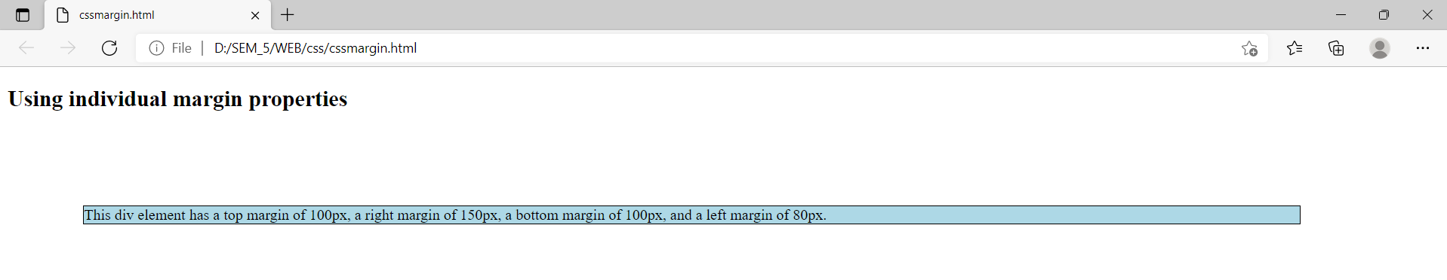

# CSS Padding

### Code:

<html>

<head>

<style>

div {

  border: 1px solid black;

  padding: 25px 50px 75px 100px;

  background-color: lightblue;

}

</style>

</head>

<body>

<h2>The padding shorthand property - 4 values</h2>

<div>This div element has a top padding of 25px, a right padding of 50px, a bottom padding of 75px, and a left padding of 100px.</div>

</body>

</html>

### Output:

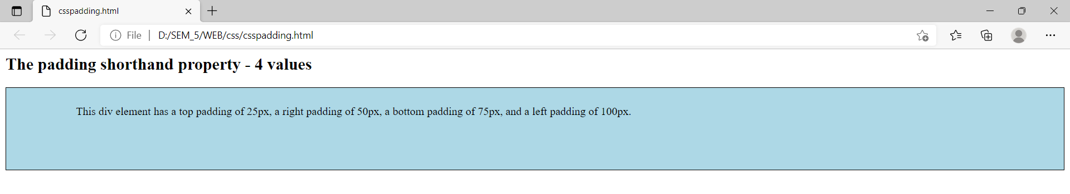

# Responsive Web Design - Media Queries

### Code:

<!DOCTYPE html>

<html>

<head>

<meta name="viewport" content="width=device-width, initial-scale=1.0">

<style>

body {

  background-color: lightgreen;

}

@media only screen and (max-width: 600px) {

  body {

    background-color: lightblue;

  }

}

</style>

</head>

<body>

<p>Resize the browser window. When the width of this document is 600 pixels or less, the background-color is "lightblue", otherwise it is "lightgreen".</p>

</body>

</html>

### Output:

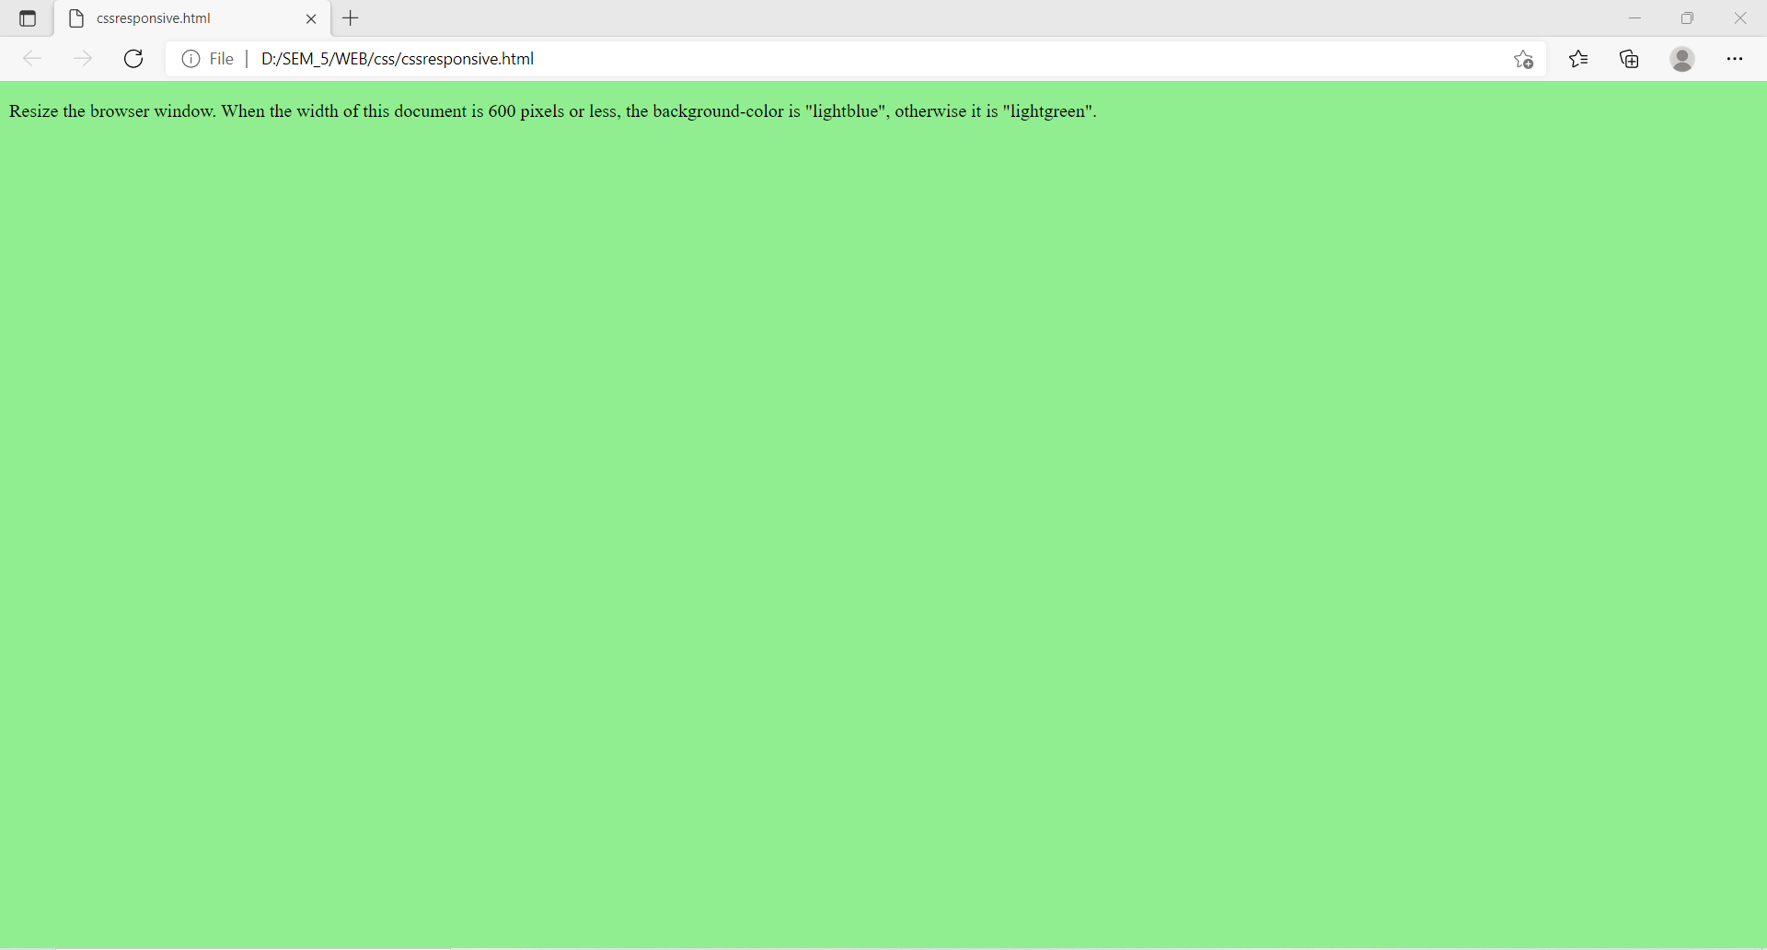

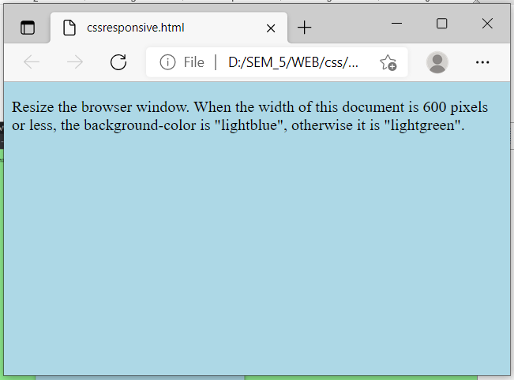

# Javascript Statements

### Code:

### 

<!DOCTYPE html>

<html>

<body>

<h2>JavaScript Statements</h2>

<p>JavaScript statements are separated by semicolons.</p>

<p id="demo1"></p>

<script>

let a, b, c;

a = 5;

b = 6;

c = a + b;

document.getElementById("demo1").innerHTML = c;

</script>

</body>

</html>

### Output:

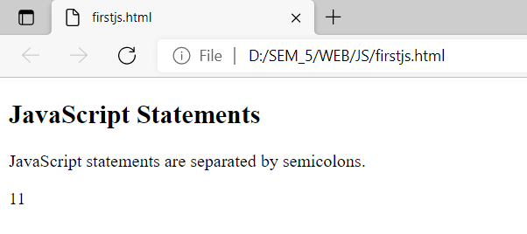

# Javascript Functions

### Code:

<!DOCTYPE html>

<html>

<body>

<h2>JavaScript Functions</h2>

<p>This example calls a function which performs a calculation, and returns the result:</p>

<p id="demo"></p>

<script>

function myFunction(p1, p2) {

 return p1 * p2;

}

document.getElementById("demo").innerHTML = myFunction(4, 3);

</script>

</body>

</html>

### Output:

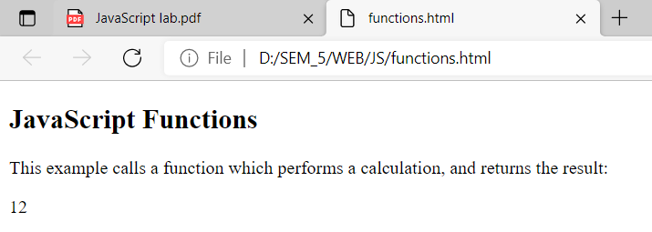

# IF Statements

### Code:

<!-- To alert Hello when user enters number divisible by 5 --!>

<!DOCTYPE html>

<html>

    <head>

        <title>If statement</title>

    </head>

    <body>

        <form>

            value <input type="text" id="txtvalue"> <br>

            <input type="button" value="OK" onclick="check()">

        </form>

    </body>

    <script>

        function check() {

            var n=Number(document.getElementById("txtvalue").value);

            if(n%5==0)

            {

                alert("Hello!");

            }

        }

    </script>

</html>

### Output:

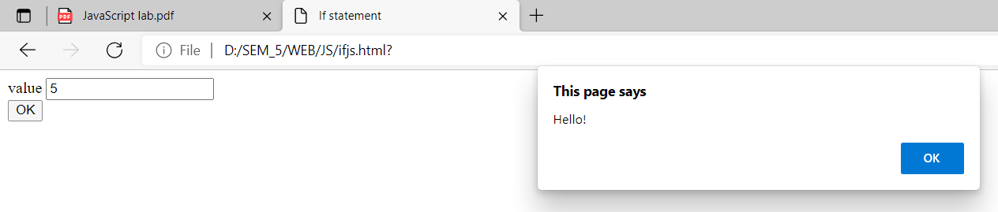

# FOR LOOP

### Code:

<!DOCTYPE html>

<html>

    <head>

        <title>Sum of first 'n' Natural No.</title>

    </head>

    <body>

        <form>

            Enter Number <input type="text" id="txtnum"> <br>

            <input type="button" value="Sum" onclick="sum()"><br>

            Result<input type="text" id="txtresult">

        </form>

    </body>

    <script>

        function sum() {

         var n=Number(document.getElementById("txtnum").value);

         var s=0;

         var i;

         for (i=1;i<=n;i++)

         {

             s=s+i;

         }

         document.getElementById("txtresult").value=s;

        }

    </script>

</html>

### Output:

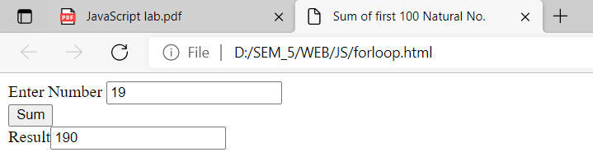

# Javascript Arrays

### Code:

<!DOCTYPE html>

<html lang="en">

  <head>

    <meta charset="UTF-8" />

    <meta http-equiv="X-UA-Compatible" content="IE=edge" />

    <meta name="viewport" content="width=device-width, initial-scale=1.0" />

    <title>Sum Of Array</title>

  </head>

  <body>

    <form action="" id="sum">

      <input class="number" type="number" name="number1" id="" />

      <input class="number" type="number" name="number2" id="" />

      <input class="number" type="number" name="number3" id="" />

      <input class="number" type="number" name="number4" id="" />

      <input type="submit" value="calculate" />

      <div id="result"></div>

    </form>

    <script>

      const form = document.getElementById("sum");

      const resultDiv = document.getElementById("result");

      const arr = [];

      form.addEventListener("submit", (e) => {

        e.preventDefault();

        const numberInputs = document.getElementsByClassName("number");

        let sum = 0;

        for (const input of numberInputs) {

          arr.push(Number(input.value));

        }

        sum = arr.reduce((number, acc) => {

          return acc + number;

        });

        resultDiv.textContent = `Sum is ${sum}`;

      });

    </script>

  </body>

</html>

### Output:

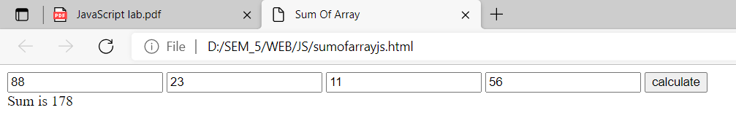

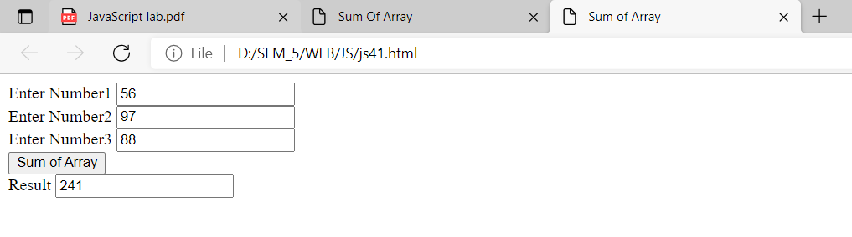

# Javascript Constructors

### Code:

<!DOCTYPE html>

<html>

<body>

<h2>JavaScript Object Constructors</h2>

<p id="demo"></p>

<script>

function Person(first, last, age, eye) { // Constructor function for Person objects

 this.firstName = first;

 this.lastName = last;

 this.age = age;

 this.eyeColor = eye;

}

const myFather = new Person("John", "Doe", 50, "blue");// Create a Person object

// Display age

document.getElementById("demo").innerHTML =

"My father is " + myFather.age + ".";

</script>

</body>

</html>

### Output:

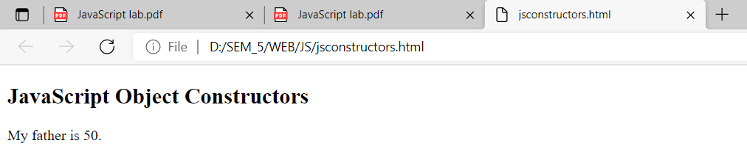

# Cookies

### Code:

<!DOCTYPE html>

<html lang="en">

<head>

    <meta charset="UTF-8">

    <meta http-equiv="X-UA-Compatible" content="IE=edge">

    <meta name="viewport" content="width=device-width, initial-scale=1.0">

    <title>Cookie</title>

</head>

<body>

    <form>

        Your Name<input type="text" id="txt"><br>

        <input type="button" value="Write Cookie" onclick="setcoookie()"><br>

        <input type="button" value="Read Cookie" onclick="readcoookie()"><br>

    </form>

</body>

<script>

    function setcoookie(){

        var name = document.getElementById("txt").value;

        if(name!= ""){

            document.cookie = "name="+name+";";

            alert("Cookie is set.");

        }

    }

    function readcoookie(){

        var name = "";

        name = document.cookies;

        alert(name);

    }

</script>

</html>

### Output:

*Write Cookie*

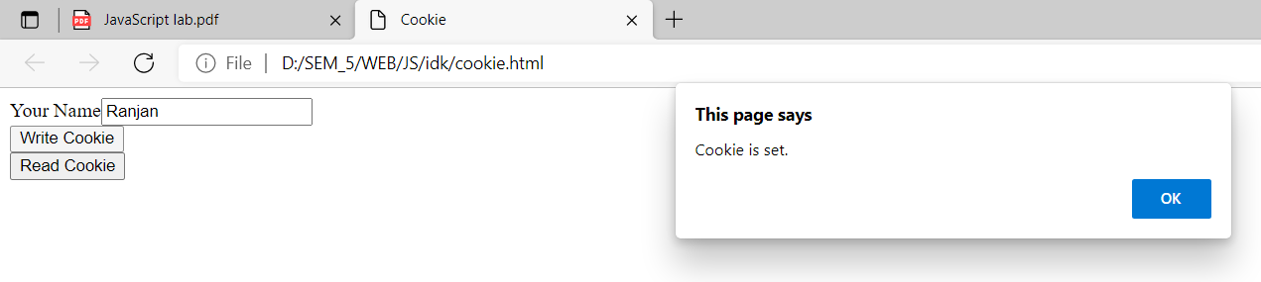

*Read Cookie*

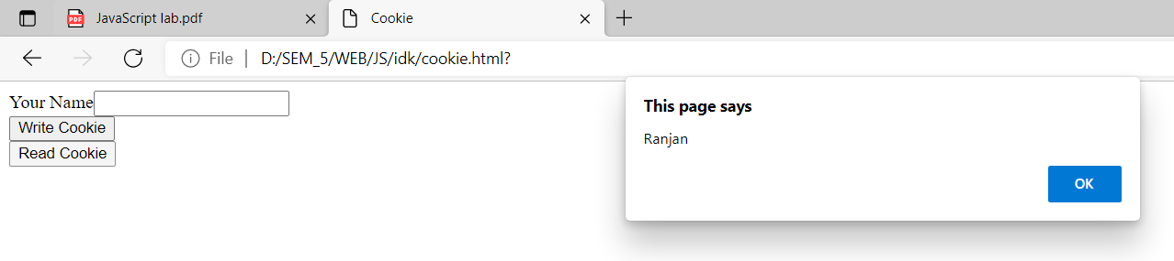

# XML

### Code:

<?xml version = "1.0" encoding="UTF-8" standalone="yes"?>

<document>

  <employee>

    <name>Ranjan Khanal</name>

    <roll>12</roll>

    <address>Kshetrapur</address>

  </employee>

  <employee>

    <name>Anjan Dhakal</name>

    <roll>18</roll>

    <address>BusPark</address>

  </employee>

  <employee>

    <name>Sabin Adhikari</name>

    <roll>69</roll>

    <address>Narayangarh</address>

  </employee>

</document>

# Accessing Form Elements with PHP

### Code:

<!DOCTYPE html>

<?php

    $a=0;

    $b=0;

    $c=0;

    if(isset($_POST["btnsum"])){

        $a = $_POST["txt1"];

        $b = $_POST["txt2"];

        $c = $a + $b;

    }

?>

<html lang="en">

<head>

    <meta charset="UTF-8">

    <meta http-equiv="X-UA-Compatible" content="IE=edge">

    <meta name="viewport" content="width=device-width, initial-scale=1.0">

    <title>Sum</title>

</head>

<body>

    <form action="firstphp.php" method="post">

        Value1<input type="text" name="txt1" value="<?php echo $a;?>"><br>

        Value2<input type="text" name="txt2" value="<?php echo $b;?>"><br>

        <input type="submit" value="sum" name="btnsum"><br>

        Result <input type="text" name="txtresult" value="<?php echo $c;?>">

    </form>

</body>

</html>

### Output:

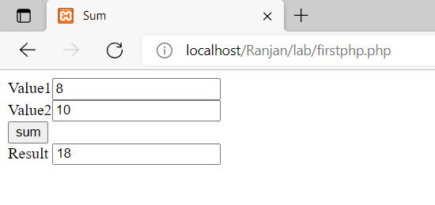

# PHP Class and Objects

### Code:

<?php

class student{

    public $name=" ";

    public $phone=" ";

    public $age=0;

    function __construct($name,$phone,$age){

        $this->name=$name;

        $this->phone=$phone;

        $this->age=$age;

    }

    function show(){

        echo("<br>Name: ".$this->name);

        echo("<br>Phone:".$this->phone);

        echo("<br>Age:".$this->age);

    }

}

$obj = new student("Ram","1234",5);

$obj->show();

?>

### Output:

